It’s Time to get your Entry In!!

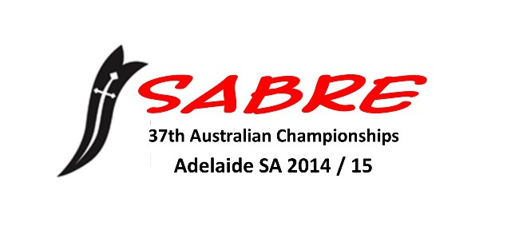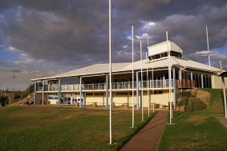

28th December 2014 - 4th January 2015 Adelaide Sailing Club – South Australia
The Sabre Sailing Association of SA has been working hard to ensure the upcoming Nationals will be an event not to be missed! This will be the first time the nationals will be held at Adelaide Sailing Club, West Beach SA - be a part of this large fleet racing and enjoy the company of many, many Sabre sailors from around Australia!
Adelaide Sailing Club (ASC) is the perfect venue for the Nationals. The club has hosted many state, national and world championships and we have secured an experienced Race Committee team that are sure to keep us happy on the water. There is ample space for rigging with a large grassed rigging areas right in front of the club. All racing will be held on the Gulf of St Vincent in front of the club so great spectator viewing is a given. Bring your family along, the club has a great family atmosphere and the venue is located close to the City, the beautiful Adelaide beaches and the tourism precinct of Glenelg. The club will be open for meals most nights and we have some great social functions planned.
The Notice of Race and Entry details are now uploaded to www.sabre.org.au or www.adelaidesabrenats2014-2015.com. An online entry with secure card payment facility has been established using http://www.trybooking.com/97103 and is the preferred method of entry.
The SA Association has also sought sponsorship from many companies to ensure this regatta is a success. We would like to thank these sponsors for their support.
Should you wish to be added to our mailing list for updates on the Nationals please let us know, email us laveray@optusnet.com.au

