Minutes of Meeting of SSAA Office bearers + SSA National Measurer + Brett Young
Thursday 9 October 2014
31 Riverside Ave Balwyn Nth Vic

These minutes record a meeting held between office bearers + the National Measurer of the SSAA with Brett Young. Refer agenda & accompanying notes prepared by Brett which were distributed ahead of the meeting.
In attendance were:
Laura Baker (National President)
Andrew Graham (Vice President)
Barry Eastgate (Secretary & Treasurer)
Nick Mouat (National Measurer)
Gary McLennan (Victorian Committee – by invitation)
Brett Young (longest serving Sabre builder of 27+ years)
Andrew Graham acted as Chairman, and provided introductory comments and outlined the intended approach to conducting the meeting (attached)
Comments from Brett Young
- Brett indicated that his motivations and actions were purely about protecting and saving the Sabre class. He indicated that he had sold both of his moulds and therefore had no financial interest in the Sabre class currently to show his intentions were for the class and not financial benefit.
- He said that his two key concerns were i) the potential for the class to be ‘attacked’ from overseas in terms of overseas builders attempting to take over the class and /or supplying boats of poor quality and ii) the need for improving the tightness of our measuring rules and procedures to maintain the one-design and flat-panel plywood heritage of the Sabre
- He said he was concerned at precedents being set by boats that are receiving A certificates despite what he felt were clear major ‘pushing of the boundaries’ - citing a Tasmanian boat with rounding of the rear chines and a WA boat with a sloping foredeck and 100mm off the bow sheerline.
- He commented that he regarded our copyright protection over the Sabre design as very weak; and only a ‘hearsay copyright’ based only the longevity of the class. He said the class needs to be as strong as those registered with ISAF – but without actually being with ISAF
- Brett wants us to honour the plywood heritage of the class given we are the custodians of the class on behalf of Rex Fertell. He feels we must honour plywood shapes and not allow shapes that cannot be replicated in plywood. When this happens – both plywood and FRP builders can achieve the same shapes, and plywood owners don’t feel they are unfairly biased against.
- Brett said that he put the downfall of numerous other flat-panel plywood classes in Australia to their inability to ‘get this right’ and to try to protect shapes just with numerical measurements rather than by clearly preventing shapes that cannot be achieved in plywood. He added that classes with excessive numbers of or undue complexity in measurement rules inevitably proved a major turn-off for the amateur builder.
- Brett made the comment that ‘he’s put things in place to ensure that the class is protected.
Improving the measurement rules & process
- It was noted that there is not currently a single master set of templates for the class – there were clear differences in shapes between various metal / paper / digitized versions. This was seen as a good reason to ‘start again’ with a master version – which would be in keeping with the idea generated at the April Measurement meeting to use Sabre 1610 as the basis for a new master set of templates. (this boat was that used for the shape of the 2 YMS moulds)
- It was noted that software such as Rhino permit 3D scanning for as little as $1000. Such scanning permits the 3D images to then be converted to 2D shapes that can form the basis for our new templates. It was agreed that this is an approach that we should take.
- Given the likelihood that a boat like 1610 is right on certain minimum measurement points – we would need to consider adding a few mm in certain areas so that some tolerance is achieved. It was noted that the resulting templates could actually be printed showing exactly where the original 1610 shape was on the template
- The resulting shape would then be made available on a CD / USB to those building a Sabre – such that a person could give the digitized templates direct to a plywood supplier and have the shapes cut
- Additionally the Association would produce mylar versions of the templates for measurement purposes to prove that neither additions nor excessive trimming was undertaken to the panels.
- It was agreed that there was the potential to add a couple of new measurement rules such as a chine to sheerline measurement and a fullness of bow test. (but Brett would prefer not, as to keep it simpler if possible for home builders)
- Additionally, consideration should be given to introducing a new measuring procedure using a batten to ensure that no inappropriate curves are present in panels.
- Also agreed that it should be a new requirement that all new plugs to be used to produce new FRP moulds will be to be inspected by the national Measurer; and that the first say 5 production boats inspected and scrutinized.
- Much discussion took place regarding are strong view held by Brett that we needed a clear and unambiguous measurement rule that all plugs used to create moulds for FRP boats must be made of plywood and not MDF. He noted that all Sabres from inception till recent times had all derived from plywood shape and none from free curves or from handshaped MDF. Agreement on this point however was not reached. Nick noted that a counter – argument was that plywood was a product that could be bent into more shapes than could MDF and he did not see the use of MDF as the threat that Brett did. This however to be an area for further consideration.
Pros & Cons of allowing non-professional building of FRP Sabres
Brett did not agree with the SSAA’s view that allowing amateur boat builders to build FRP Sabres was undesirable and felt that we needed greater evidence of where it had been inappropriate in other classes. (SSAA committee members were not able to provide such evidence at the meeting and hence this needs to be further researched). Brett noted that amateur FRP has worked successfully in multiple other classes with flat panels including the Int Fireball for over 60 years and tabled multiple classes where he believed amateur FRP building was successful in and had extended the life span of the class involved. He noted that in all these classes no drop in professionally built boat values were seen.

Following some discussion, it was agreed that a potential area to explore would be to ensure that a suitably qualified professional builder was designated as the licensed builder for any mould, and that that builder would be responsible for the quality of any /all FRP Sabres that were built from that mould whether work was undertaken by the builder himself, his staff, or amateurs wishing to be part of the building of their Sabre.
Protecting the Association’s copyright over the Sabre design
Brett indicated that the Sabre Association needed to take steps to protect the ownership of the design of the Sabre given the potential for overseas interests to exploit the weak copyright position. He said we should be concerned that large overseas boat builders could potentially swoop on the class and copy the design. He added that in his view, the builders of the imported Sabres brought into Australia in late 2013 and again in the past month had taken a near straight copy of the YMS hull and deck mould.
After some discussion – the preferred approach for the Association in this area will involve:
- Lodging our digitized plans for copyright
- Early movement to introduce a mould licensing and builder licensing regime to control who can build FRP Sabres, ensure the quality of the resulting boats, permit greater scrutiny that the plugs / mould measure, and to assist in the protection of the IP of other builders,
- Approaching ISAF to say ‘we exist’ – ie to formally let them know that we are a class of 40 years existence, 2000 boats built, copyright lodged, and a properly established class association
Other issues raised
Brett raised a number of other issues, including:
- Brett expressed the view that the national association would be better served with introducing a concept he called a ‘Regional Commodore’ which would be a person serving as the ‘Chairman’ of the SSAA and doing so for periods longer than that currently served by the revolving one year president.
- Brett tabled examples of new A certificates that were much more tamper-proof and longer lasting than our current stickers. Cost would be around $4 each
- Various new ‘tidy up’ rules
- A new format for the class rules (preferably in line with ISAF template) and a separation from the construction notes to reduce confusion on what is actually a rule or what is measureable.

Appendix :
SSAA Executive meeting with Brett Young 9 Oct 2014
Opening comments from Andrew Graham

- Were a lot of reasons why this meeting would not have eventuated - and it says much for the goodwill from each of you that we’ve gone ahead with it. Brett - you've obviously lost a lot of sleep over all this - but your passion for the class and your huge knowledge of the whole area of rules and measurement have clearly pushed you on. Nick - you've felt under siege much too often this year and yet that doesn't change the fact that the skill base that you bring to the job I think is without parallel in the class's history. Laura - you've stuck in there and kept us together as a team despite this having got far more personal than it ever should have. And meanwhile Barry has handled a workload on the secretarial front that is without precedent given last years rule changes, the charter, and now the rule & constitution dramas.

- It has been a very very difficult 12 months in terms of communications regarding the measurement and related topics that we are going to discuss tonight. I guess in hindsight we’d have saved most of us here and various others a lot of stress and time and preserved relationships if things had played out differently. I just hope we can rule a line under a few things once we conclude tonight.

-tonight it’s important to stress that virtually everything that we’ll discuss is about measurement. And therefore we’re very much dealing with issues that are the primary responsibility of Nick as National Measurer. And so if Nick says No, or says I’ll look into that, or will put it on the agenda for discussion at next measurers’ meeting , or says wants to think more about it or whatever - then I don’t want to see any more discussion or debate about it tonight

- We don’t want to see us wasting our precious time tonight delving back into history. Neither events of 10 years ago nor I would suggest who said what in 2014.

- I think it worth noting that this is very much pioneering territory for the SSAA. Having a physical meeting of the office bearers, yet alone the extent of communication over the past 9 months - it’s a big leap forward for us. Particularly when coupled with the sheer extent of activity on the measurement front

- Tonight’s discussions could readily go all night, or get ugly, bogged-down, go off on tangents or fail to resolve anything. We are going to have to work hard to avoid that. I’ve agreed to chair the meeting - and Gary is going to be my unofficial deputy to try to keep us focussed and on track. And so Brett - if or when we say we want to move on - lets move on to ensure the success of the evening.

- I’m hoping that an early thing we can achieve is establishing common ground. I have little doubt that there exists more common ground than we might think - particularly in terms of what has emerged in recent days. So let’s not spend too much time debating things that we’re all reasonably aligned about. Let’s focus on the potential solutions.

- Do want to spend a moment to remind us all of the SSAA's broad intended pathway for the next 6 months or so. Stage 1 is completing the steps to make absolutely sure that our constitution and past decisions are all bullet proof. We've completed the national vote to formally amend our constitution and have lodged it with CAV. A vote to ratify all past national decisions including the Nov13 measurement rules changes will be the next step. After that we want to get our charter / spirit of rules agreed and voted on. We are happy to be looking at and if agreed act on mould licensing and builder registration during the same time period. Only after that will we look at the broader area of alterations to measurement rules, combining building notes and rules and so on. That process will involve seeking written submissions from the Sabre building community & sail makers, and will include full socialisation within the Sabre measuring community ahead of any move to put it to the states for voting. It is going to be a very busy period for the SSAA

Appendix 2

Suggested Agenda and Points of Note for Meeting Thursday 9 October 2014
From Brett Young

- Brett very keen to listen to SSAA progression to date.
- Templates shape control

  - New templates Mylar and Jpeg to autocad possibilities
  - So all Sabres Internationally from same templates via e-programming

What is the status of the templates being made by SSAA?
- Importance of a universally tight set of rules –

- Mistakes learnt from similar classes – Mirror, 125, Sharpie, Heron NS14 v’s Tasar(originally same design)
- To measure via panel templates v’s measurement system….

Produced a split in the classes due to faster boats
Decimated 2nd hand values
Mirror – Measurement system made it too hard for amateur builders to adhere to (too tight)
Heron – Multiple divisions needed to handle different hull shapes – fleets within the fleet.
125 National fleet decimated by a re-interpretation of measurement rules. Went from 6 FRP builders to only one now.
Sharpie “Comfort” hull scenario split Sharpie fleet, friendships and fleet numbers ever since.
Lack of tight rules has allowed RS to come into global marketplaces and decimate local design, fleets, boating manufacture, sail makers, and other associated industries.
People like tight control – this is what currently sells boats –in addition, it ensures the end users investment is safe. E.g. early/old boats are still competitive
An example that we should consider following is the Fireball.
Panels have less than 3mm curvature allowed in one plane, which has forced panels to remain the same curvature as achieved by plywood and therefore needs minimal measurements to control its curve fore and aft.
It is an ISAF class which does not need expensive ISAF templates to measure it.
Boats can be built by amateurs and professionals and have successfully been done internationally for over 50 years.
- International Control
- Hull shapes
- Construction
- Class Rules
- Building licences – Internationally controllable
- Copyright protection internationally
- Class rule protection internationally

1st growth bubble of Sabres after one set of templates from 1 boat, owned by 1 man = consistency.
2nd local growth bubble due to quality and consistency of designs in FRP matching Plywood
Australian numbers can be seen as minimal – far greater growth bubbles could occur anywhere in the world at any time.
If these numbers did happen overseas – how can we control these designs?.........
And how can we prevent local Sabres being controlled or overrun by international players.
The Sabre is one of very few popular home built boats that could suit the international market…..(as the Mirror filled a place in its time)
This makes it popular, but also a hindrance or threat for new designs trying to enter the Australian market.

By strictly controlling the design, class rules relating to it and the builders, you control and protect the class outright – internationally and locally.
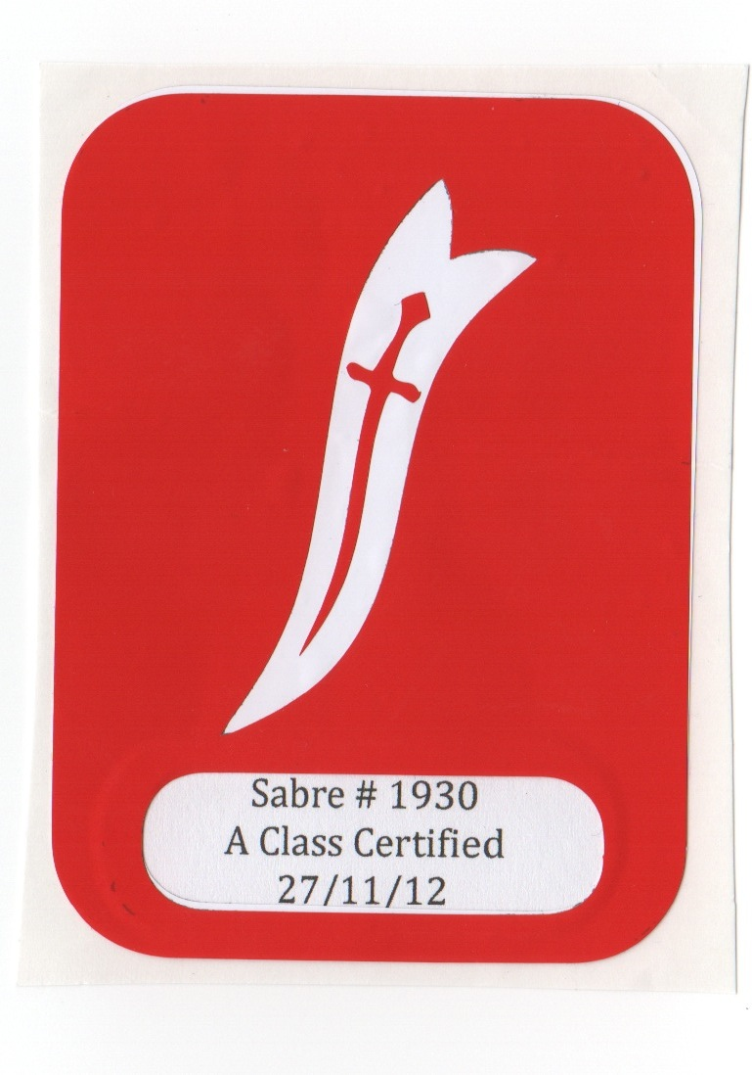
- New A-Class plaque lifetime sticker

A way of controlling amateur and professionally built boats via supply and licensing.
A vinyl sticker is only issued to the boats and builders that comply.
New design, A class-certified sticker will be both tamper proof and last the lifetime of the boat.
Samples provided……..
- Regional Commodores – Internationally and Australia

This has been a highly successful process in other classes by having a longer term position e.g 3-5 years in a neutral position separate from the position of National President.
This allows for greater consistency of thoughts and direction while allowing the local president the honor of being National president for the National Championship in their own state.
E.g so we have more long term, neutral thinking members around the country involved around the country to give a wider perspective/balance along the lines of Barry Eastgate and Andrew Graham, that act to give consistency and continuity to ongoing committes and decision making.
Also, with our minor international fleets, by bestowing a local commodore-ship for that region, it should ignite growth by doing so.

- Additional new rules for inclusion in class rules

- Use of transom flaps and drain plugs while racing, plus dimensions of transom flaps (We have currently limited that to 80 x 40 mm)
- Minimum length and size of centerboard handles
- Distance of rudder leading edge from transom
- Minimum weight of rudder assemblies for FRP to prevent light ‘one offs’.
- Reduction of 3kg of lead back to original amount of 2Kg
- 12 mm anti tamper tape for black bands for cost saving.
- Better worded construction notes for FRP and Plywood.
- Better worded pre-face and ‘Spirit of Class’ rule to give correct intent of Class and designer’s original concept of plywood shaped boats.

- New format for class rules and separation from construction notes

Referring back and forth from outdated construction notes to latest rules has been universally agreed to cause most confusion.
All rules and measurements MUST be self inclusive – (in their own rules and measurement section)
A new up-to-date and simple to read measurement form – with a separate measurers notes handbook on how to correctly interpret them.

- Risk - should the current proposals by SSAA be implemented

  - The class will fracture
  - New numbers will decline/growth will suffer
  - Control lost to other bodies e.g RS or Overseas operations could register to join ISAF and take control away from SSAA
  - Existing sailors will leave the fleet due to frustration
  - Resale values dropping
  - The RS Aero is about to be launched in Australia Oct/Nov. This boat is the nearest competitor to the Sabre concept, but STRICTLY one design.
They have sold 300 boats since launching it.

